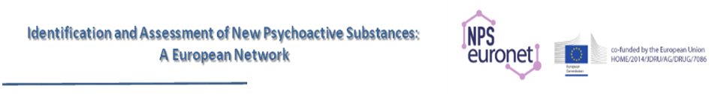

NPS-Euronet Conference

Lisbon, April 16th 2018

Registration Form

Name....................................................................................

Family name........................................................................

E-mail address.....................................................................

Institution............................................................................

Country................................................................................

The participation to the conference is free of charge, but pre-registration is required.

Reply to "Ivana Garimoldi" ivana.garimoldi@marionegri.it

